*IOT based Smart Irrigation System Using nodeMCU and ThingSpeak for surveillance of crops*

Chaitanya Kamasani   
*Btech Student,*  
*Departmemt of Computer Science*Vellore Institure of Technology

Chennai , India  
Email : Chaitanyainfo27@gmail.com

Chaitanya Sai G   
*Btech Student,*  
*Departmemt of Computer Science*Vellore Institure of Technology

Chennai , India  
Email : charansai2002.cs@gmail.com

*Abstract*—Automation of farm moves can convert farming place as of presence labor-intensive and still to smart and energetic most important to developed production with lesser human regulation. this paper proposes an automated irrigation gadget which keeps and monitors the selected soil moisture content via automatic watering. nodemcu is used as controller unit.the layout makes use of soil moisture sensors which degree the precise moisture degree in soil. this cost lets in the machine to use suitable amount of water which sidesteps over/ underneath irrigation. iot is used to preserve the farmers updated approximately the grade of motor. records from the soil moisture sensor, dht11 sensor is often updated on the thingspeak web page thru which a farmer can test whether or not the water motor is on/off at any given time. also, the sensor readings are transmitted to a issue talk channel to generate graphs for evaluation.

Keywords—Automation,thingspeak,IOT,nodeMCU.)

# **Introduction**

Irrigation is making use of water to the land artificially. water is one of the precious useful resource and important factor for farming. general troubles in farming is underneath watering or over watering the problems are nice explained with the aid of answering the easy query that when the water cycle began and the way long watered..?? underwatering is starting the water cycle too late and running it for no longer enough period due to this the crop may be damaged and it impacts the manufacturing. overwatering is beginning the water cycle too early and going for walks it for longer length than what it is essential by using doing this exercise the crop can be broken and manufacturing reduces. if human intervention is greater then this under and over watering takes vicinity due to small human errors. the primary object of this paper is to reduce human intervention and growth the irrigation performance by automating the irrigation system the use of sensors(moisture and dht11) and tracking via thingspeak net web page. india owns agrarian economy with 70% of population depending upon agriculture immediately or in – at once [6]. in this sort of developing usa wherein digitization is given high precedence, technology is showing its optimization in diverse fields while it nonetheless calls for footprints into irrigation so present day smart move inside the discipline is significantly advocated. the trouble with modern-day irrigation system are (a)shortage in water and energy definitely required for plant boom (b)traditional methods of farming are accompanied requiring-a great deal man-electricity (c)nonremunerative for the farmer as the price of manufacturing is improved. so there is a need to make a few changes in modern-day device.

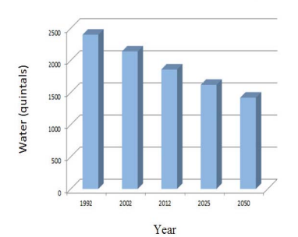

Fig. 1. Water Availability

# **Literature Survey**

Pushkar Singh and SanghamitraSaikia introduced the design and implementation of an Arduino-Based Smart Irrigation System. The Arduino-based communication has been created to ease the function, application, maintenance and the price.The device is fully automated and reliable. Sensors interact with the website communication system from a large distance in nanoseconds which makes the user more prolific. The entire system is based on the arduino which use inexpensive microcontroller;this system can be applied to large areas for relatively small investment [3].

S. Darshna, T.Sangavi, Sheena Mohan, A.Soundharya, SukanyaDesikan proposed Smart Irrigation System. In the current scenario, manually controlled irrigation method is used by the farmers, in which farmers sprinklethe land at systematic periods. The process depletes more water and the outcome is water loss. While dry areas have less rainfall and irrigation is challenging. Thus there is a need for an automated system that will accurately control and monitor the amount of water needed in the fields. Introducing IOT based smart irrigation system which preserves time and assures prudent uses of water. Furthermore, this design uses Esp8266 WiFi module and microcontroller which assure a rise in system life by diminishing power consumption [1].

Ravi Kishore Kodali and Borade Samar Sarjeraopresent the Low Cost Smart Irrigation System Using MQTTProtocol.Efforts have been made to make an easy water pump controller based on soil moisture sensor and are useful in the agriculture sector using Esp8266 NodeMCU-12E.Esp8266 NodeMCU-12E is inexpensive, uses a small microcontroller in size and consumes less power which makes the proposed system suitable for the given operation. Transport Layer Security (TLS) and Secure Socket Layer (SSL) cryptographic protocols provide system security. Soil moisture sensor is highly accurate which give analog readings and measures the value of soil moisture correctly. This mobile app and web page displays the soil moisture price and water pump state [4].

G. Parameswaran and K.Sivaprasath introducedanArduino Based Smart Drip Irrigation System Using Internet of Things.This irrigation system gives better production than prior and water usage is limited.Due to routine updates to the server and getting the proper knowledge of the system indefinitely, the production rate may also increase in some unusual circumstances. It mitigates the human work, power and cost. The server updates farmers about the nature of the crop area and everything else. [2].

PriyankaPadalalu, SonalMahajan, KartikeeDabir, SushmitaMitkar and DeepaliJavale proposed Smart Water Dripping System for Agriculture. The presented model control and monitor accurately the water necessity in the field automatically. Smart irrigation system assures prudent use of water. This design uses a microcontroller which increases system life and curtails power consumption. This water dripping system has proposed a smart solution for proper utilization of water which is a very big problem in flourishing countries like India. The whole system is easy to operate by using the android system [5].

# **PROPOSED WORK**

## Smart Irrigation System Solution:

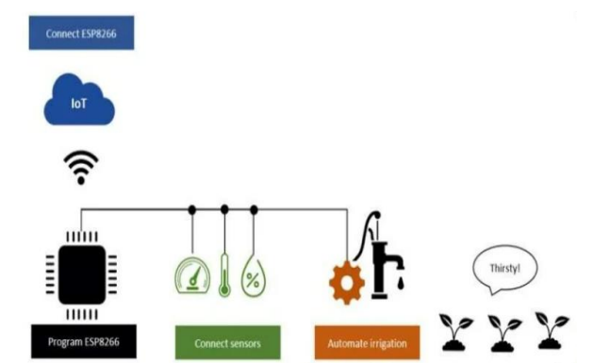

Clever irrigation answers are the evolving trend in each day lives. the generation has finished a full circle via giving lower back to irrigation the modernday developments and techniques which have been evolved. connectivity the usage of present wifi networks the use of the to be had hardwares is one important gain for clever agriculture. Smart irrigation answers and hence could cause the successful increase of net of factors implementation within the subject of agriculture. that evolution is that which overcomes the existing conventional cell computing situation of clever phones and their apps and innovate into connecting of the gadgets inside the surrounding to assist with an answer for the realistic problem that needed to be treated..

## Sensor Module

Sensors are the real need of the arena that assist to experience their environment and consequently assist human beings to govern the surroundings without their presence. given their utility, they're the most complex gadgets that are being used extra regularly everywhere. agriculture sensors need to be more sensitive to weather modifications and also robust in nature of the exposure they're need to confront. many business sensors are to be had within the marketplace and we simply need to pick out the appropriate one so one can fit the want of the day. Many factors affect the choice of sensors. few of them that want to be noted are great, the environment in which they may be implemented, the measurability range of the sensor, readings which are determined through the sensor, sensitivity response time, identification of the studying that varies in a static surroundings and ultimate but no longer the least the value of the detector.

* Soil Moisture Sensor module
* DHT11 Temperature and Humidity Sensor Module

## Power Supply Module :

The electricity deliver of 5v is generated the usage of the above schematic. step down transformer is used for 12v supply and bridge rectifier regulator and filter out are used to supply 5v supply that's used within the circuit

## IOT :

Internet of things (iot) is extensively used in connecting gadgets and amassing records records. internet of things is used with iot frameworks to handle and engage with statistics and statistics. within the device customers can register their sensors, create streams of data and process records. iot are applicable in diverse methodologies of agriculture. packages of iot are smart towns, smart environment, clever water, clever metering, security and emergency, business control, smart agriculture, home automation, e-fitness and so on. ‘net of factors’ is based on device which is able to analysing the sensed records after which transmitting it to the person. in these approach we are using thingspeak cloud page for tracking the Sensors information. the data is amassed from the sensors and displayed graphically on the thingspeak cloud web page so that it is straightforward to reveal.

## Water Module :

Water motor is used to pump the water mechanically to the plant which requires by means of the use of the sensors records.

* 5V 10A Relay Module
* 3V to 12V Mini DC Submersible Pump

## WORKING :

Iot based totally clever irrigation gadget which is capable of automating the irrigation procedure by way of analyzing the moisture of soil and the weather circumstance. additionally the facts of sensors could be displayed in graphical form on thingspeak cloud page.

While the power deliver is at the microcontroller exams the soil moisture content material. if the moisture content isn't as much as the threshold then it makes the motor to get on automatically and turns off routinely if reaches the threshold stage.

Whilst the whether circumstance is such that it's far raining then the microcontroller puts off the motor until then raining. after the raining it tests for threshold and makes the important motion. If the strength deliver is off unexpectedly then after the energy is on microcontroller turns on automatically there may be no want of manually turn on and rancid the motor.

All of the information from the sensors and water is graphically shown inside the thing speak iot cloud page which is used for monitoring Advantages of these technique is that it's miles a cost powerful irrigation controller, growth efficiency and reduce wastage, smooth to screen, reduces man fee, decreased run off water and vitamins.

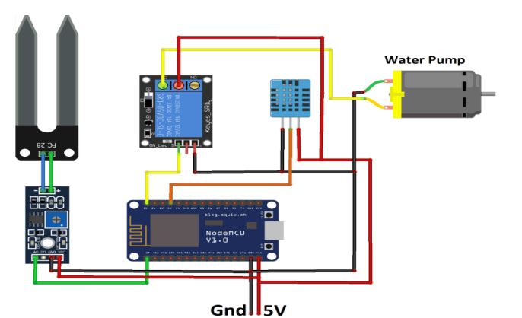

Fig. 2. Circuit diagram

# **Results and discussion :**

The goal of the project was to put into effect the modern technology in required fields like agriculture. usage of iot idea makes the entire system of cropping clean. right here a few degree of automation is performed in terms irrigating mechanically.

The benefits as mentioned like water-saving and laborsaving are required the maximum in current agricultural state of affairs. consequently it's miles proved using the sensor networks again making clever irrigation. the information from iot is despatched to the client using cloud.

consequently, any versions inside the crop may be identified effortlessly and early analysis is achieved as such. the facts is in graphical shape so we will easily screen

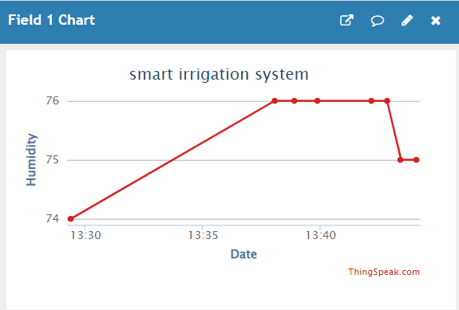

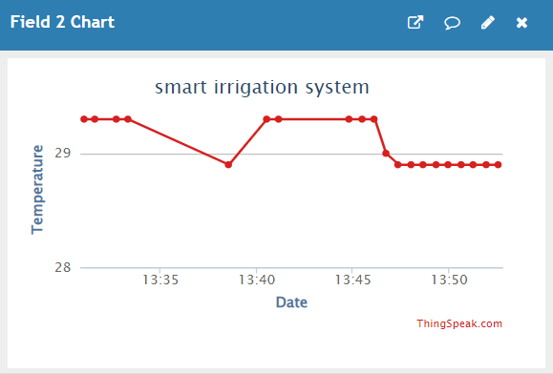

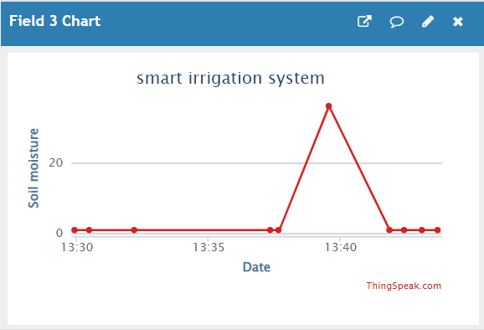

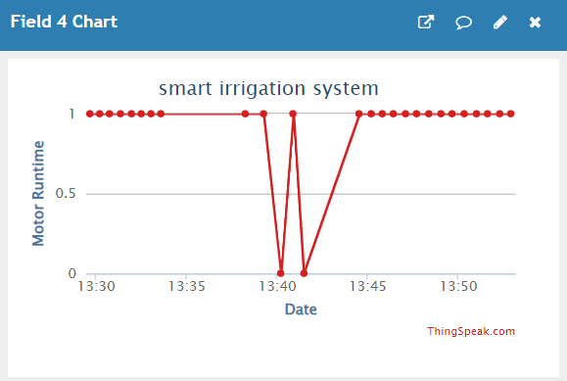

# CONCLUSION

Hence, the paper proposes an concept of mixing the state-of-the-art generation into the rural field to show the conventional methods of irrigation to modern methods for that reason making easy effective, and cost-effective cropping. some extent of automation is brought permitting the idea of tracking the sphere and the crop situations within a few lengthy-distance tiers using cloud offerings. the benefits like water saving and hard work-saving are initiated the usage of sensors that work automatically as they're programmed. this concept of modernization of agriculture is easy, low-cost and operable. for this reason, the paper proposes an idea of combining the modern generation into the agricultural subject to show the conventional strategies of irrigation to trendy strategies therefore making clean productive, and within your budget cropping. a few quantity of automation is added permitting the concept of tracking the sphere and the crop situations inside some lengthy-distance degrees using cloud offerings. the advantages like water saving and labor-saving are initiated the usage of sensors that paintings automatically as they're programmed. this concept of modernization of agriculture is easy, inexpensive and operable.

# FUTURE WORK

Large ability of our indian agriculture is but untapped and we still have miles to tour in this arena of studies as we've specific soil textures in different areas of our kingdom. farmers may be benefitted through the real implementation of this projected software. real demanding situations that had been faced and which can be but to be triumph over in fact are the internetworking of the nodes in an agricultural area and in designing a user pleasant software this is without difficulty comprehensible for the farmers.

##### References

[1] S. Darshna1, T.Sangavi, Sheena Mohan, A.Soundharya,Sukanya,“Smart Irrigation System”, IOSR-JECE, May – Jun 2015.

[2] G. Parameswaran and K.Sivaprasath,“Arduino Based Smart Drip Irrigation System Using Internet of Things”, IJESC Volume 6 Issue No. 5.

[3] P. Singh and S. Saikia, “Arduino-based smart irrigation usingwater flow sensor, soil moisture sensor, temperature sensor andESP8266 WiFi module”, 2016 IEEE Region 10 HumanitarianTechnology Conference (R10-HTC), Agra, India, 2016, pp. 1-4.

[4] Ravi Kishore Kodali and Borade Samar Sarjerao, “A Low Cost Smart Irrigation System Using MQTT Protocol”, IEEE Region 10 Symposium (TENSYMP), Cochin, India, 2017, pp. 1-5.

[5] PriyankaPadalalu, SonalMahajan, KartikeeDabir, SushmitaMitkarandDeepaliJavale, “Smart Water Dripping System for Agriculture/Farming”,2nd International Conference for Convergence in Technology (I2CT), Mumbai, India, 2017, pp. 659 – 662.

[6] IJACT:International Journal of Advancements in Computing Technology, 2.Vol. 4, No. 5, pp. 83-90, 2012. [16] Xun-yi Ren, Lin-juan Chen, Hai-shan Wan, "Homomorphic Encryption and Its Security Application", JDCTA: International Journal of Digital Content Technology and its Applications, Vol. 6, No. 7, pp. 305- 311, 2012.

[7] Ken Cai.” Internet of Things Technology Applied in Field Information Monitoring”, Advances in information Sciences and Service Sciences AISS, Vol.4, No.12, pp.405-414, 2012.

[8] Zhao Xing, Liao Guiping, Shi Xiaohui, Chen Cheng and Li Wen. “Construction of agricultural service mode in IOT and cloud computing environment” [J]. Journal of Agricultural Mechanization Research, Vol.4 pp.142-147, 2012.

[8] Zhao Xing, Liao Guiping, Shi Xiaohui, Chen Cheng and Li Wen. “Construction of agricultural service mode in IOT and cloud computing environment” [J]. Journal of Agricultural Mechanization Research, Vol.4 pp.142-147, 2012.

[9] Liu Hai, He Chaobo,Tang Yong, Huang ShiPing.” Research and Application of Service-Oriented Scholar Cloud Platform”, Journal of Convergence Information Technology JCIT,Vol.7, No.5, pp.333-339, 2012.

[10] Harjit Singh Lamba,Gurdev Singh, "Cloud Computingfuture Framework for e-management of NGO’s",International Journal of Advancements in Technology,Vol.2, No. 3, pp.400-407,2011. <http://baike.baidu.com/view/2302276.htm>

[11] “Virtualization and Cloud Computing Group”. “Virtualization and Cloud Computing” [M]

[12] Beijing: Publishing House of Electronics Industry, China, 2009.

[13] Li Hang,Chen Houjin, Key technology and application prospect of the internet of things, Forum on Science and Technology in China, 2011.

[14] Mo Lianguang, Study on Supply-Chain of Agricultural products Based on IOT, 2014 Sixth internet International.